CST 205: Multimedia Design & Programming

Brian Sheridan & Kevin Bentley

Midterm Project Outline

Topic:

Produce a filter that will make any picture more CSUMB-y. For this project we will be creating a banner that will overlay on top of a picture that will have the CSUMB name imprinted in it. Also we will be installing the CSUMB otter logo at the bottom right hand side of the picture regardless of image size. The purpose of the filter is to celebrate an accomplishment at CSUMB. The three items we will modify are installing the end caps for the border, extending the banner to reach both sides of the end caps, installing the CSUMB logo at the bottom right of the picture, and adding text to the banner.

Sources:

* The first aspect will to be finding a banner a modifying it to allow for a manipulation across a wide range of photos. The banner has been placed on a green background.
  + [Banner](https://mbtskoudsalg.com/explore/blue-banner-clipart-png/#gal_post_3317_banners-clipart-rectangle-1.png)



* The CSUMB logo will be attached to the image at the bottom right of the image.
  + [CSUMB Logo](https://csumb.edu/affairs/logo#heading-b7a1ddf9-fe89-484f-91be-5c11105c0c70)



* Add text to the banner “CSUMB Class of 2020”. Allow text to be centered in the banner regardless of the size of picture.

Current Project Progress:

This filter is currently in production and is working to an extent. We have got the CSUMB logo to populate without any problems. The banner we are modifying to allow for to be placed on a wide array of photos.

Double-y Filter

Topic:

The filter will blend two pictures together regardless of the image size. The purpose would be to create new and interesting images. The three objects that will be modified will be each of the two pictures for blending and the sizes of each picture to allow for blending. Also we will be adding the CSUMB logo at the bottom right of the photo.

Sources:

* Adjust the size of both images to maximize the usable space between them both
  + Ideas for code

<https://stackoverflow.com/questions/38914527/make-two-column-responsive-images-of-same-size>

* There will be two types of blending that we will try:
  + Loop through other y-value and copy the pixels from the first image. The same will happen with the second image but there will be an offset to the first image.

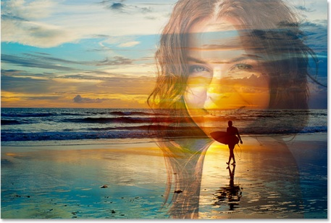

<https://www.photoshopessentials.com/photo-editing/how-to-merge-layer-blend-modes-in-photoshop/>

* The CSUMB logo will be attached to the image at the bottom right of the image.
  + [CSUMB Logo](https://csumb.edu/affairs/logo#heading-b7a1ddf9-fe89-484f-91be-5c11105c0c70)



Current Project Progress:

We currently have the first blending technique working for the same size images. We are working on the second technique and resizing the images to have more compatibility through different size images.

